Software Requirement System

CSET 115
Weekly Assignment 1

Sept. 25, 2025

Submitted by
Vasquez-Mesa, Juan

Submitted to
Ashraful Huq, Mohammad

Table of Contents
CSET 115 1
Sept. 25, 2025 1
Table of Contents 2
1. Is software manufactured, engineered, or both? What’s the difference between software manufacturing and software engineering? How does this difference impact the software Lifecycle? 4
2. How likely is software to fail as time passes? 4
3. Why must software change? 4
4. How would you define software engineering, and how does it differ from traditional engineering disciplines? 4
5. What is the difference between: a. Software engineering and system engineering? 4
6. Describe David Hooker’s general principles of software engineering. 4
7. Are the following statements facts or fiction? If fiction, provide the correct facts: 4
8. What is a software process model? 4
9. List and describe the stages of a prescriptive model. 4
10. Describe the waterfall model in detail. 4
11. Describe the V-model with a diagram. 4
12. Describe the stages of planning in the V-model. 4
13. What is the difference between high-level design (HLD) and low-level design (LLD)? 4
14. Describe the advantages and disadvantages of the incremental model. 4
15. What is an evolutionary process model? 4
16. What is agile? 4
17. State and describe the agile values. 4
18. What is XP (Extreme Programming)? 4
19. State five agile principles that you think are the most important. Explain your choice. 4
20. State five XP practices that you think are the most important. Explain your choice. 4
21. What are the differences between Scrum and traditional software development methodologies such as the waterfall model? 4
22. Explain the Scrum framework in detail, including the role of the: 4
23. Describe the three key Scrum artifacts: a. Product backlog 4
24. What is the importance of sprint ceremonies in Scrum? 4
25. Explain the concept of “incremental development” in Scrum. 4
26. Describe the “Definition of Done” (DoD) in Scrum. 4
27. Explain the concept of "velocity" in Scrum. 4
28. Compare the concepts of "sequential" vs. "overlapping" work as used in Scrum. 4
29. What is an “information radiator” in Scrum, and why is it important? 4
30. What challenges do distributed teams face in Scrum, and how can they overcome them? 4
31. What is the role of a Sprint Retrospective, and why is it essential for continuous improvement? 4
32. Describe how risk is managed in Scrum compared to traditional project management approaches. 4
33. How does Scrum handle changing requirements during the project lifecycle? 4
34. How does the Scrum Master ensure the removal of impediments that affect the team’s productivity? 4
35. What is a burn-down chart, and how is it used to track sprint progress? 4
36. Explain the importance of cross-functional teams in Scrum. 4
37. Discuss the difference between Scrum and Kanban. 4
38. What is the importance of a "self-organizing team" in Scrum? 5
39. Describe how you would handle a scenario where stakeholders keep changing the product vision mid-sprint. 5
40. How does the Sprint Planning meeting ensure alignment between the Product Owner and the development team? 5

1. Is software manufactured, engineered, or both? What’s the difference between software manufacturing and software engineering? How does this difference impact the software Lifecycle?
- Software is only engineered, the difference falls in that engineering is the planning, designing and development of the actual software (Michigan Tech, 2024), while software manufacturing is the mass creation of a product using machinery which cannot be done for a digital form or work. The impact this distinction has is that if someone is trying to create software and attempts to use a mentality based on manufacturing they won’t be able to perform as well as someone who uses a mentality backed on the ideas of software engineering.

2. How likely is software to fail as time passes?
- As time goes on in a software’s life the chances of failure goes down steeply the initially high risk comes from the ideas and concepts being fleshed out as well as the chances of design mistakes being extremely high. Once some time has passed the rate of failure chance decreases, but as changes/ implementations are made the risk quickly spikes due to the increase of complexity that comes from combining units into a whole software.
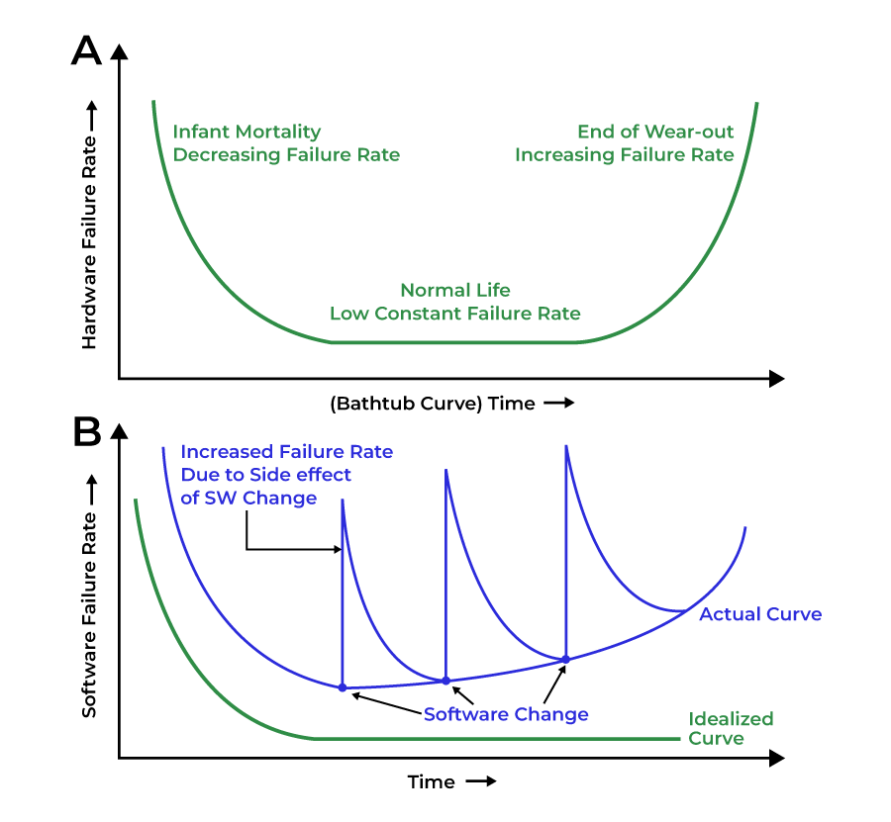Image from: (GeeksforGeeks, 2023)

3.Why must software change?
- Software has to change to keep up with customer expectations. This is seen with the constant updates Windows has in its versions, with each version becoming more modern and providing more functions for the users. YouTube has also changed a lot to maintain its growth with its addition of YouTube shorts to align with the change in attention span seen in the younger audience (Jaworski, 2023).

4.How would you define software engineering, and how does it differ from traditional engineering disciplines?
- Software engineering is the process of creating a list of instructions to complete a task. Following this the traditional engineering disciplines focus on physical creations, software engineering focuses on creating digital non-tangible works.

5.What is the difference between:
a. Software engineering and system engineering?
- Software engineering is creating digital instructions to accomplish a specific given task. On the other hand system engineering is made around managing multiple components and ensuring that they are able to function accordingly, but focusing on the whole of a project, being the hardware, software and other functions and components.
b. Software engineering and computer science?
- Computer Science is the study of computers and the systems that are used for computations. This study is about the interaction between the hardware and software of a system and how the systems are designed. This is different from Software Engineering in which SE is about the creation of softwares and the process of creating them, CS is the understanding of how/ why they work and the theories behind the creation of them.

6.Describe David Hooker’s general principles of software engineering.
- The Reason it all Exists: Systems are made with the intent to provide value to the customer, and this should be kept in mind when creating the software.
- KISS (Keep It Simple, Stupid!): The system should be as simple as can be, this is important because it must be able to be maintained and understood by outside parties.
- Maintain the Vision: A vision must be made for the software project early on and without keeping it throughout the process.
- What You Produce, Others Will Consume: When making something keep in mind that people in the future will also have to understand what you made.
- Be Open to the Future: Consider what possibilities could come from the possible actions a consumer can do, never think that all customers will follow the same logic as you do.
- Plan Ahead for Reuse: create the functions and software as a whole with the plan of using parts of the software in the future or allowing features to be implemented in future use scenarios.
- Think! : Before you do something, understand what you are going to do, this will increase the value and the results of what you make, as well as learn from what you do too.

- All of these principles came from a software engineering document (UNIT 1, n.d.).

- As a whole, all of these features help software developers work effectively and intelligently, in providing a guide that will help them in current projects as well as future projects.

7.Are the following statements facts or fiction? If fiction, provide the correct facts:
a. Once developers deliver their software product, their job is done.
- This is not true at all, even after they deliver a product they still can learn from what they did, and maintaining that information makes them a stronger developer. In addition developers can stay with the customer to maintain the product and update to provide continuous value even after publication.
b. Planning is unnecessary in software engineering. The best practice is to dive into
coding right away.
- This statement is false, coding without a plan will in the end cause a lack of structure, increasing the chance of risk in failure and decreasing value for the whole project. Creating a strong project plan will allow the team to set goals and milestones to ensure progress is being made and if they are on track to finishing by the due date.
c. Modern software is flexible. It is not difficult to incorporate changes into it.
- This may or may not be true depending on the team that designed the software and the project as a whole. Software should be made to be flexible and easy to incorporate changes but some software is not designed in such a case so this statement could be true or false.

8.What is a software process model?
- A software process model is a set of steps to ensure value, and efficiency while making a software. Process models provide examples of possible steps a team can take to maintain organization and work throughout a software’s life cycle, the multitude of different processes allows for varying teams and projects to have steps specially designed for each one.

9.List and describe the stages of a prescriptive model.
- The stages of a prescriptive model often are communication, planning, modeling, construction, and deployment.
- In communication the team (usually team manager) talks with the customer about what they want the product to include and what the project as a whole is.
- Planning is where the team decides what the goals/milestones will be .
- Modeling is outlining what the projects will have and what it should look like by the end.
- Construction is both the creation/coding of the program as well as the testing for each unit.
- Deployment is sending the product live to get feedback and to build on it in future releases.
A prescriptive model requires that each stage is completely done and 100% finalized before moving on to the next step. This creates a rigidity that removes any sense of flexibility from projects.

10.Describe the waterfall model in detail.
- The waterfall method is a process model in which each step is done in a linear manner and no step is ever done twice, each step has to be ensured to be completed completely before moving on. This model is a prescriptive model, in its rigidity and heavy dependence on documentation. It follows the steps of gathering information for the requirements and analysis, System design, Implementation of the code, testing and verifying the code works, Deployment, and Maintenance.
- Requirements gathering involves understanding and documenting everything the customer wants.
- The system design involves the outlining of what is needed for the functions to be accomplished, in the hardware, software, and other components to ensure values to the customer.
- Implementation is the actual coding of the software and the creation of the actual product.
- Testing involves verifying that the combination of all the functions work to ensure that they function according to the customer’s desires.
- Deployment is where the product is sent to the customer or live.
- Maintenance comes in the forms of updates to improve the software after release.
Waterfall is best when the product is simple or the idea is clear and concise. If the customer is unsure of what they truly want, the waterfall should not be used or if the project is extremely complex.

11.Describe the V-model with a diagram.
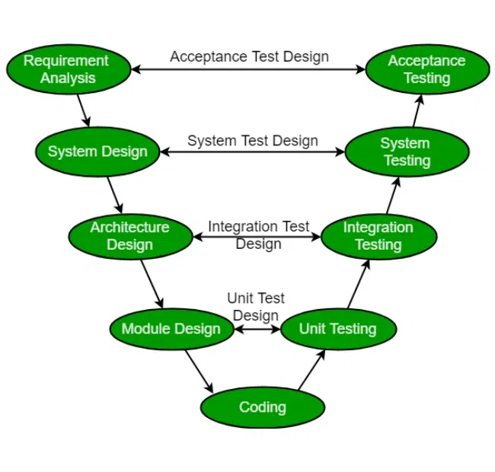(GeeksforGeeks, 2018)
- The V-Model has more checks between the testing of the code and the design, this ensures more reliability early on. In Waterfall each phase is done in order and testing is only done at the end but in V-Model testing is done at each step so there is less of a risk later on that the functions will not work correctly together. Still has a lot of the strictness of Waterfall but reduces the risk of making a product the customer does not want with the amount of checks early on. This process still risks a lot of money if changes need to be done.

12.Describe the stages of planning in the V-model.
- While you create a plan you also need to create a plan for the test that will be done after the code is made. Alignment between development and testing is ensured by having the planning requirements being made in mind with the tests as well.

13.What is the difference between high-level design (HLD) and low-level design (LLD)?
- High level design includes how the system functions between each component, while low level design plates a major focus on each component of the system. Both of these work together by highlighting the steps involved in software development, like the designing of the system as a whole is the High level design while creating each unit is the Low level Design.

14.Describe the advantages and disadvantages of the incremental model.
- Advantages of the incremental model is the constant feedback loop from the customer allowing a higher level of understanding of the product view for the team. Focusing on a single unit allows for more time and effort being put into a single component instead of doing the whole project all at once.
- Disadvantages are the risk in the complexity in the project as the amount of increments increase. The cost of the Project is much higher due to having to repeat a set of steps multiple times.
- Waterfall has the risk come into play at the beginning because of how much importance is made into the plan and outlining of the project. While incremental has the low but happening often throughout the creation with the user’s idea having to be outlined at the beginning of each unit.

15.What is an evolutionary process model?
- An evolutionary process model aims at changing a software product over time in iterations to achieve the final end goal of the project. Customer feedback is often an important component in the start of each iteration. 2 types of evolutionary process models are the Spiral Model and the Iterative model.
- The Spiral model combines the linear process of waterfall with the iterations of the incremental model. The advantage of this is the constant feedback creates a flexibility that allows changes to occur throughout the whole project’s life. The disadvantage is the large amount of time it takes to release a product.
- The iterative model repeats the steps of a linear process and after an iteration is made the team checks with the customer if the iteration is made to the liking of the customer. An advantage of the iterative model has the advantage of higher product quality due to the frequent testing. On the other side it has a downside of being harder to track because of the constant iterations.

16.What is agile?
- Agile is a set of values and beliefs that allows a team to make decisions while producing/ developing a software. Agile allows the team to be flexible and more self-orientated than a traditional development team.

17.State and describe the agile values.
- The values are; Individuals and Interactions over Processes and Tools, Working Software over Comprehensive Documentation, Customer Collaboration over Contract Negotiation, Responding to Change over Following a Plan. Usually traditional development often goes against these values and prioritizes a linear process and being directed by the customer’s ideas and planning.
- Individuals and Interactions over Processes and Tools: This value puts importance on having conversations in person over using technology/ online forms of conversation.
- Working Software over Comprehensive Documentation: This means that the whole purpose of the software is to provide value to the user.
- Customer Collaboration over Contract Negotiation: The customer should be an active member during the software development process with continuous feedback instead of the team having the initial requirements being set by a contract.
- Responding to Change over Following a Plan: The team should be open to changes made by the customer, and actively expects this.

18.What is XP (Extreme Programming)?
- Extreme programming is a methodology under Agile. It takes the principles of Agile to the extreme, especially expecting change from the customer. This method requires a lot of planning before a sprint has started and if a change is desired it has to be postponed until a sprint is over.

19.State five agile principles that you think are the most important. Explain your choice.
- Customer satisfaction through early and continuous delivery of valuable software
- Welcome changing requirements, even late in development
- Deliver working software frequently, with a preference for shorter timescales
- Collaboration between business people and developers throughout the project
- Working software is the primary measure of progress
- These principles have a similarity in being that they push for high quality and communication. These two are what I find to be a highlight of Agile in comparison to traditional processes, in the best way possible even. These ideas can be seen with each iteration with a large focus on communication and working as speedy as possible.
20.State five XP practices that you think are the most important. Explain your choice.
- Pair Programming
- Collective Ownership
- Coding standards
- Sustainable pace
- On-Site customer
- The principles of XP are great and should always be thought of when working but these 5 truly stand out among the rest. These principles put a lot of priority in teamwork and communication, which is often and truly a make or break in my eyes when it comes to SDLC projects. These principles promote faster feedback with the requirement of the customer to play a larger role in development.

21.What are the differences between Scrum and traditional software development methodologies such as the waterfall model?
- The Scrum method has more independence with the developer team in decision making compared to other classical methods. Scrum does not require a super defined planning phase. Scrum is flexible unlike the traditional model of waterfall . Unlike classical methodologies Scrum is based on the people who are working instead of the plan allowing change to occur throughout the project's development. The iterative nature takes a long time to create the actual product.

22.Explain the Scrum framework in detail, including the role of the:
- Scrum framework is backed behind the ideas of providing flexibility for the team, transparency between the team and the customer, and collaboration between both parties but best if done in an in person manner. The goal of this framework is to produce high quality value in a short period of time, with anyone being able to see the progress as the team works in short sprints. The teams that follow this framework are self-managed and it comes from the different responsibilities placed on the team, like the Product Owner, their job is to maximize the value of the product as well as managing the product backlog. The Scrum Master has the job of Supporting the team as they develop the project ensuring efficiency is maintained and no distractions affect the team. The Scrum Master also makes sure that the team follows the principles as they move forward in the project, understanding the theory, practicing, rules and values of Scrum. Finally the main development team of this group has the job of using their skills to actually produce some sort of value after a sprint. These roles work together to allow the team to run through sprints efficiently and correctly, the whole team is meant to be able to make an incremental product quickly because they have more freedom and voice throughout each sprint, with the end goal of each early sprint to get feedback and with the end goal of having a high value product for the customer.

23.Describe the three key Scrum artifacts:
- a. Product backlog: This is where the team outlines what tasks are the most important to get through and which ones are the least important, as well as the implementations that have to be added.
- b. Sprint backlog: The team and only the team creates a backlog in which they plan what tasks will be done during the following sprint, this updates everyday.
- c. Increment: Also known as a sprint are iterations of a project, these sprints are meant to be done in a short period, being about 1 month. During the sprint the product is being designed, tested and coded, and no changes can occur during the sprint.

24.What is the importance of sprint ceremonies in Scrum?
- Sprint ceremonies are designed to allow the team to verify the progress made during the previous sprint, and outline what will occur in the following sprint. This encompasses Sprint Planning, the Daily Scrum, the Sprint Review, and the Sprint Retrospective, but each term has its own idea. These work together to provide continuous improvement by checking and ensuring that work has been made, and tracking what needs to be done and has been done. Sprint retrospective adds on the opinions of the development team allowing the higher ups to know how productivity can be kept and boosted.

25.Explain the concept of “incremental development” in Scrum.
- Incremental development in scrum teams works on adding to the previous iteration made of a project, done in short periods allowing quick feedback from the customer to see what needs to be implemented and kept in the next sprint. This is completely different from waterfall in which waterfall has everything done in a single set of steps done in sequential order, only just that each step has to be ensured to be done 100% before moving on. This is completely different from Scrum’s more lenient and flexible approach to combating these kinds of tasks.

26.Describe the “Definition of Done” (DoD) in Scrum.
- Definition of done is a state that an increment can have after all possible requirements have been met (scrum.org, n.d.). The whole team has to agree because DoD is either a 100% yes or a 100% no, because features have to be completed in all senses of the matter. The requirement of these being 100% done ensures that when the team moves on from the task there is no worry that they might’ve forgotten something or left the task unfinished.

27.Explain the concept of "velocity" in Scrum.
- Velocity is a term used to estimate how long a backlog item will take, usually the velocity changes throughout the whole project’s life because it is determined by how much “done” work has been made and used to estimate how fast the team can work for the next sprint. An important note as well is that it takes some iterations and practice for the team to have a solid idea of their velocity in how much work they do.

28.Compare the concepts of "sequential" vs. "overlapping" work as used in Scrum.
- Sequential aims at following a set of steps ensuring that the previous step is completed, like a single sprint in Scrum. On the other hand the idea of iterative models is seen as the whole process of Scrum with the team making a short sprint, acquiring feedback, and planning and starting a following sprint that builds off of the previous iterations, overlapping them to make the whole project. Overlapping work is encouraged due to its ability to have progress made consistently and make changes being possible with the constant feedback after each iteration.

29.What is an “information radiator” in Scrum, and why is it important?
- An information radiator is any form of visual display that demonstrates a project's progress or status to everyone. The importance of this came into the transparency it provided for the team and the stakeholders, motivating decision-making amongst the team, and holding data of current and past data and progress (Indeed.com, 2024). Common information radiators are Release Burndown charts which shows the progress towards completing a release, and Production Burndown Chart which shows the project’s project as a whole.

30.What challenges do distributed teams face in Scrum, and how can they overcome them?
- Communication between team members are difficult to maintain, the aim of scrum is to have in person conversations and meetings, trust between members are also a concern that come into play with the idea benefit of in person conversations, if the team is remote trust is sure to fall due to lack of in person peer pressure. Ceremonies and the meeting are harder to hold because not everyone will be at the meeting in person. To combat this, use video calls and if someone is doing pair programming the screen should be shared to others so the whole team can observe what work has been made. When looking for developers, remote members are expected to make the team with this issue in mind and pick people who are reliable even if communication isn’t fully one on one and understand how to use video conferencing technology.

31.What is the role of a Sprint Retrospective, and why is it essential for continuous improvement?
- Sprint Retrospective aims at allowing the development team to voice their concerns, opinions and ideas on how to promote efficiency among the team and project’s life. This differs greatly to the Sprint Review meeting with this meeting being about what progress has been made and what was done during the previous sprint, while the Sprint Retrospective aims at helping develop the team's work environment, opinion and plans for the next sprint.

32.Describe how risk is managed in Scrum compared to traditional project management approaches.
- Scrum deals with risk by having the customer play a key role in the development of the project, as well as using an interactive method which allows a more consistent feedback loop which is a highlight for the Scum method. Traditional methods reduce risk by requiring a large amount of effort and time into perfecting the plan of a project.

33.How does Scrum handle changing requirements during the project lifecycle?
- Scrum handles changing requirements during a project’s life by allowing the team to decide what features or components to prioritize before a sprint starts, or even allowing developers to add features if needed for a component of the software. On the other hand waterfall does not easily allow changes, if a change is needed it would be costly, but scrum allows these ideas to be stated in between sprints.

34.How does the Scrum Master ensure the removal of impediments that affect the team’s productivity?
- The Scrum master will identify a problem that the team is facing, see what a solution to the problem can be, act on that idea, and follow-up with the team to ensure that the idea is working as it should. This comes into the form of Daily Scrums which has the development team voice the problems they face on the daily. If a problem occurs with the computer system a developer uses to code the software, the Scrum master has the job of contacting IT to aid in fixing the computer to ensure productivity for the worker. The Scrum master will check in with the developer to make sure that the problem has been fixed and the developer is able to work. Another example is if a developer needs an external system that is dependent on a different team, the developer has to ask the Scrum Master to provide the developer a means of acquiring this external system. The Scrum Master will ask the external system team to provide the necessary tools so the Scrum team can work on the task needed. Once the Scrum master gets the necessary information or system they will provide it to the developer and follow up with the developer to make sure that the work flow is in progress as expected for the project.

35.What is a burn-down chart, and how is it used to track sprint progress?
- A burndown chart is a method to display information often being used to show progress of an aspect of a part, or a whole project. This system is used to track sprint progress because of the transparency provided by this form of visuals, as well as a good way to gauge how much longer it will take to finish a project by using the past sprints to predict the velocity of the team and how long future sprints will take. Using previous data allows the team to see as well how much progress they make on the product backlog of every previous iteration.

36.Explain the importance of cross-functional teams in Scrum.
- Cross functional teams in Scrum allows the team members to work on a different task after they finish a task they started. Having a cross-functional team allows the members to have the skills to complete every single job of a sprint from start to finish with high quality. Flexibility is a common characteristic in these types of teams, because of the diverse skill set the team can react quickly to demands and efficiently. The skill of the members allow them to make their own decisions and to be self -organizing which builds on the flexibility and quality the Scrum team produces.

37.Discuss the difference between Scrum and Kanban.
- Kanban is an agile methodology that focuses on a visualized representation of workflow, tasks can be added at any point of the software’s life, teams that use the Kanban methodology do not hold roles in the team. Kanban methodology has no process and uses the board to show what tasks need to be done, in progress, and are done in doing so any developer can start a new task after they finish the one they move on to the next priority task if they have the capacity they start the task to promote work-flow (Martins, 2025). In complete contrast a scrum team assigns roles to members to create structure, tasks are created and assigned priorities before the sprint starts. Tasks are assigned before the sprint and are not added during the sprint, unless necessary for a function or component. Kanban is designed for complicated and unpredictable projects and a high need for a flexible method of development. Scrum in contrast is best for well defined goals for projects, and a desire for iterative process.

38.What is the importance of a "self-organizing team" in Scrum?
- The self-organizing team type of scrum is important because of the flexibility that comes with this, as well as the innovations and creativity that improves quality and efficiency. A self-organizing team allows the development team to make their own choices that prevents project management roadblock. Also, developers have a sense of responsibility for their own work so they are more motivated to perform better for both of these reasons.

39.Describe how you would handle a scenario where stakeholders keep changing the product vision mid-sprint.
- If the Stakeholders want to create a change mid-sprint I would notify them that changes cannot be implemented and that it would be best if they took their time to flesh out their idea and once the next sprint occurs their idea should be more fleshed out so the planning of the next sprint is better than the last. No matter what the Scrum Master should not let changes be implemented in the middle of a sprint, both because it will go against the ideas of Scrum it will also disrupt the work flow of the developers which will cause risk for the project’s quality and efficiency.

40.How does the Sprint Planning meeting ensure alignment between the Product Owner and the development team?
- The sprint planning meeting is meant for the Product Owner to outline the backlog, which provides guidance for the task priorities and the end goal of the sprint to the development team. The key outcome of a successful sprint planning meeting is a sprint which allows the team to complete all of the tasks demanded by the Product owner, and to create a software which is very valuable and of an immense amount of quality.

Citations
GeeksforGeeks. (2018, July 13). SDLC VModel Software Engineering. GeeksforGeeks. https://www.geeksforgeeks.org/software-engineering/software-engineering-sdlc-v-model/
GeeksforGeeks. (2023, March 24). Failure Curve for Software in Software Engineering. GeeksforGeeks. https://www.geeksforgeeks.org/software-engineering/failure-curve-for-software-in-software-engineering/
Indeed.com. (2024). What Is an Information Radiator in an Agile Framework? Indeed Career Guide. https://www.indeed.com/career-advice/career-development/what-is-an-information-radiator-in-agile
Jaworski, B. (2023, November 21). Why YouTube created Shorts to compete with TikTok. LogRocket Blog. https://blog.logrocket.com/product-management/why-youtube-created-shorts/
Martins, J. (2025, January 19). What Is Kanban? A Beginner’s Guide for Agile Teams [2023] • Asana. Asana. https://asana.com/resources/what-is-kanban
Michigan Tech. (2024a). What Is Computer Science? Michigan Technological University; Michigan Technological University. https://www.mtu.edu/cs/what/
Michigan Tech. (2024b). What is Software Engineering? | Computer Science | Michigan Tech. Michigan Technological University. https://www.mtu.edu/cs/undergraduate/software/what/
scrum.org. (n.d.). What is a Definition of Done? Scrum.org. https://www.scrum.org/resources/what-definition-done
Staver, A. (2022, May 5). Software Development Planning: Why It Is Important. Bamboo Agile | Custom Software Development Company. https://bambooagile.eu/insights/software-development-planning
UNIT 1. (n.d.). https://www.pvpsiddhartha.ac.in/dep_it/lecture%20notes/SE_22/SE-Unit1-20IT3302.pdf

